1...REAL-TIME WEATHER MONITORING SYSTEM

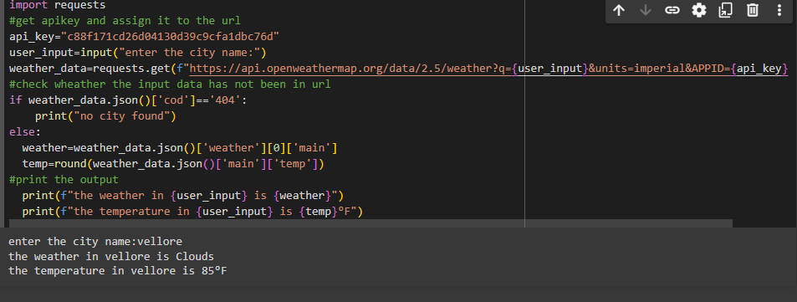

1. ….INVENTORY MANAGEMENY SYSTEM OPTIMIZATION

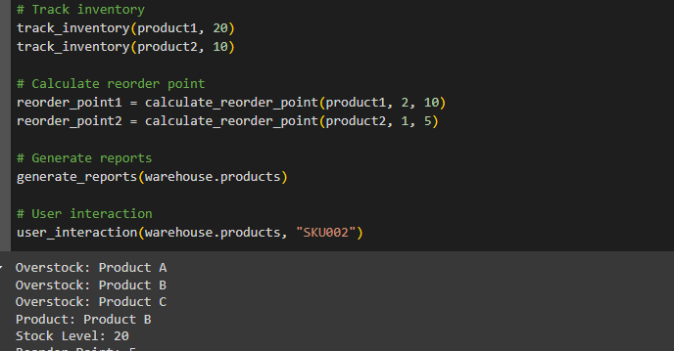

1. ….REAL-TIME COVID-19 STATISTICS TRACKER

